ASSIGNMENT 4

**QUESTION:**

Write code and connections in wokwi for ultrasonic sensor. Whenever distance is less than 100 cms send "alert" to ibm cloud and display in device recent events.

CODE:

#include <WiFi.h>

#include <PubSubClient.h>

void callback(char*subscribetopic, byte* payload, unsigned int

payloadLength);

//-------credentials of IBM Accounts------

#define ORG"Ashfaq1824"//IBM ORGANITION ID

#define DEVICE_TYPE "ESP32"//Device type mentioned in ibm watson IOT Platform

#define DEVICE_ID "12345"//Device ID mentioned in ibm watson IOT Platform

#define TOKEN "12345678" //Token

String data3;

char server[] = ORG ".messaging.internetofthings.ibmcloud.com";

charpublishTopic[] = "iot-2/evt/Data/fmt/json";

charsubscribetopic[] = "iot-2/cmd/test/fmt/String";

char authMethod[] = "use-token-auth";

char token[] = TOKEN;

char clientId[] = "d:" ORG ":" DEVICE_TYPE ":" DEVICE_ID;

WiFiClient wifiClient;

PubSubClient client(server, 1883, callback ,wifiClient);

const int trigPin = 5;

const int echoPin = 18;

#define SOUND_SPEED 0.034

long duration;

float distance;

void setup()

Serial

.begin(115200);

pinMode(trigPin, OUTPUT);

pinMode(echoPin, INPUT);

wificonnect();

mqttconnect();

}

void loop()

{

digitalWrite(trigPin, LOW);

delayMicroseconds(2);

digitalWrite(trigPin, HIGH);

delayMicroseconds(10);

digitalWrite(trigPin, LOW);

duration = pulseIn(echoPin, HIGH);

distance = duration * SOUND_SPEED/2;

Serial

.print("Distance (cm): ");

Serial

.println(distance);

if(distance<100)

{

Serial

.println("ALERT!!");

delay(1000);

PublishData(distance);

delay(1000);

if (!client.loop())

{mqttconnect();

}

}

delay(1000);

}

void PublishData(float dist)

{mqttconnect();

String payload = "{\"Distance\":";

payload += dist;

payload += ",\"ALERT!!\":""\"Distance less than 100cms\"";

payload += "}";

Serial

.print("Sending payload: ");

Serial

.println(payload);

if (client.publish(publishTopic, (char*) payload.c_str())){

Serial

.println("Publish ok");

} else {

Serial

.println("Publish failed");

}

}

void mqttconnect() {

if (!client.connected())

{

Serial

.print("Reconnecting client to ");

Serial

.println(server);

while (!!!client.connect(clientId, authMethod, token)) {

Serial

.print(".");

delay(500);

}initManagedDevice();

Serial

.println();

}

}

void wificonnect()

{

Serial

.println();

Serial

.print("Connecting to ");

WiFi.begin("Wokwi-GUEST", "", 6);

while (WiFi.status() != WL_CONNECTED)

{delay(500);

Serial

.print(".");

}

Serial

.println("");

Serial

.println("WiFi connected");

Serial

.println("IP address: ");

Serial

.println(WiFi.localIP());

}

void initManagedDevice() {

if (client.subscribe(subscribetopic))

{

Serial

.println((subscribetopic));

Serial

.println("subscribe to cmdOK");

} else {

Serial

.println("subscribe to cmdFAILED");

}

}

void callback(char*subscribetopic, byte*payload, unsigned int payloadLength)

{

Serial

.print("callback invoked for topic: ");

Serial

.println(subscribetopic);

for (int i = 0; i < payloadLength; i++) {

//Serial.print((char)payload[i]);

data3+= (char)payload[i];

}

Serial

.println("data: "+ data3);

data3="";

}

**SCHEMATIC/CIRCUIT DIAGRAM:**

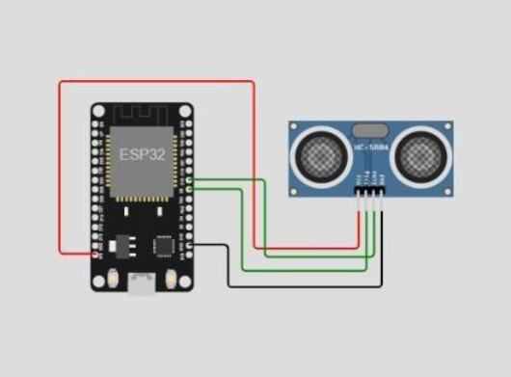

**IBM CLOUD OUTPUT:**

